//Q.."""write a python program to demonstrate dictonary"""

a={}    #empty dictionary

b={'a21004':'hibban','a21005':'ramsha','a21006':'bushra'}

print(b)

OUTPUT:



//Q."""write a python program to demonstrate the string"""

a=input("enter the name:")

for i in range(0,len(a)):

    print(a[i],end=" ")

b=input("enter the any string:")

print()

print(a+b)

OUTPUT:

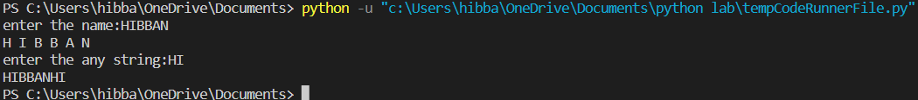

//Q."""write a python program to demonstarte the list"""

from random import randint

a=[]

for i in range(0,10):

    a.append(randint(0,100))

print("the list is:",a)

OUTPUT:



//Q."""write a python program to demonstarte operator

    1.assignment operator

    2.comaprison operator

    3.arithematic operator

    4.logical operator

"""

#1.assignment operator

a=5

b=6

a=b#assignment operator

print(a)

#2. comparison operator

a=5

b=6

print(a>b)

print(a<b)

print(a==b)

print(a>=b)

print(a<=b)

#3.arithmetic operator

a=5

b=6

print(a+b)

print(a-b)

print(a/b)

print(a//b)

print(a%b)

print(a\*b)

print(a\*\*b)

#4.logical operator

a=True

b=False

print(a and b)

print(a or b)

a=False

b=True

print(a and b)

print(a or b)

OUTPUT:

